**SETTI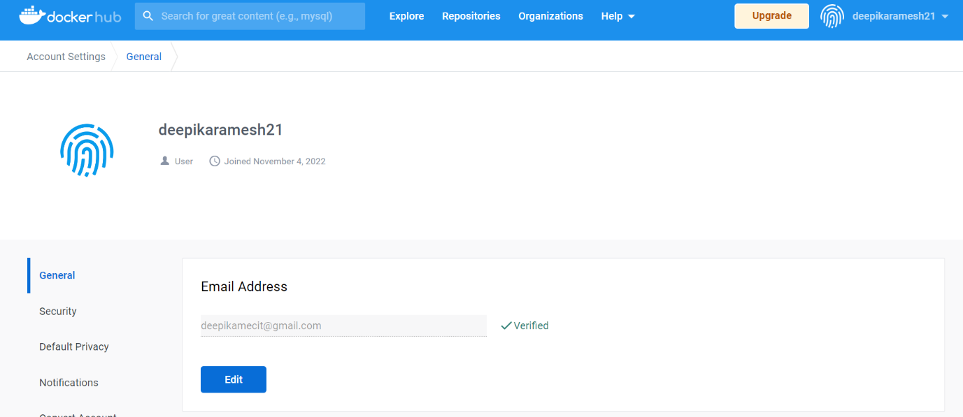NG UP APPLICATION ENVIRONMENT**

**DOCKER INSTALLATION**

|  |  |
| --- | --- |
| Date | 26 October 2022 |
| Team ID | PNT2022TMID19236 |
| Project Name | News tracker applications |
| Maximum Marks | 8 Marks |